HEALTHCARE Analysis

Week3:
Data Visualization and Insight Communication

- Introduction
Data visualization helps convert raw healthcare data into easy-to-understand charts, graphs, and dashboards. Visual representations allow hospitals, doctors, and healthcare administrators to identify trends, compare patient information, and make informed decisions. It describes the key healthcare metrics to be visualized, the visualization tools, proposed dashboard design, and how these visualizations support healthcare decision-making.
Healthcare datasets contain large amounts of information that are difficult to understand in tabular form. Data visualization simplifies complex information by presenting it in graphical formats such as charts, graphs, and dashboards.
The objective of this phase is to design visualizations that clearly communicate healthcare insights and support data-driven decisions.

- Task Objective

The objectives of data visualization are:
- Understand patient demographics.
- Identify common medical conditions.
- Compare billing amounts.
- Analyze admission trends.
- Monitor test results.
- Present findings using interactive dashboards.

Visualization Tools

The following tools will be used:
Tool | Purpose
Python | Data Analysis
Matplotlib | Basic Charts
Seaborn | Statistical Visualization
Power BI | Interactive Dashboard
Jupyter Notebook | Analysis Environment

- Proposed Visualization

Visualization | Purpose
Bar Chart | Common medical conditions
Pie Chart | Gender distribution
Histogram | Age distribution
Box Plot | Billing amount analysis
Line Chart | Patient admissions over time
Count Plot | Admission type comparison

- Mock Up Or Wireframes Ideas

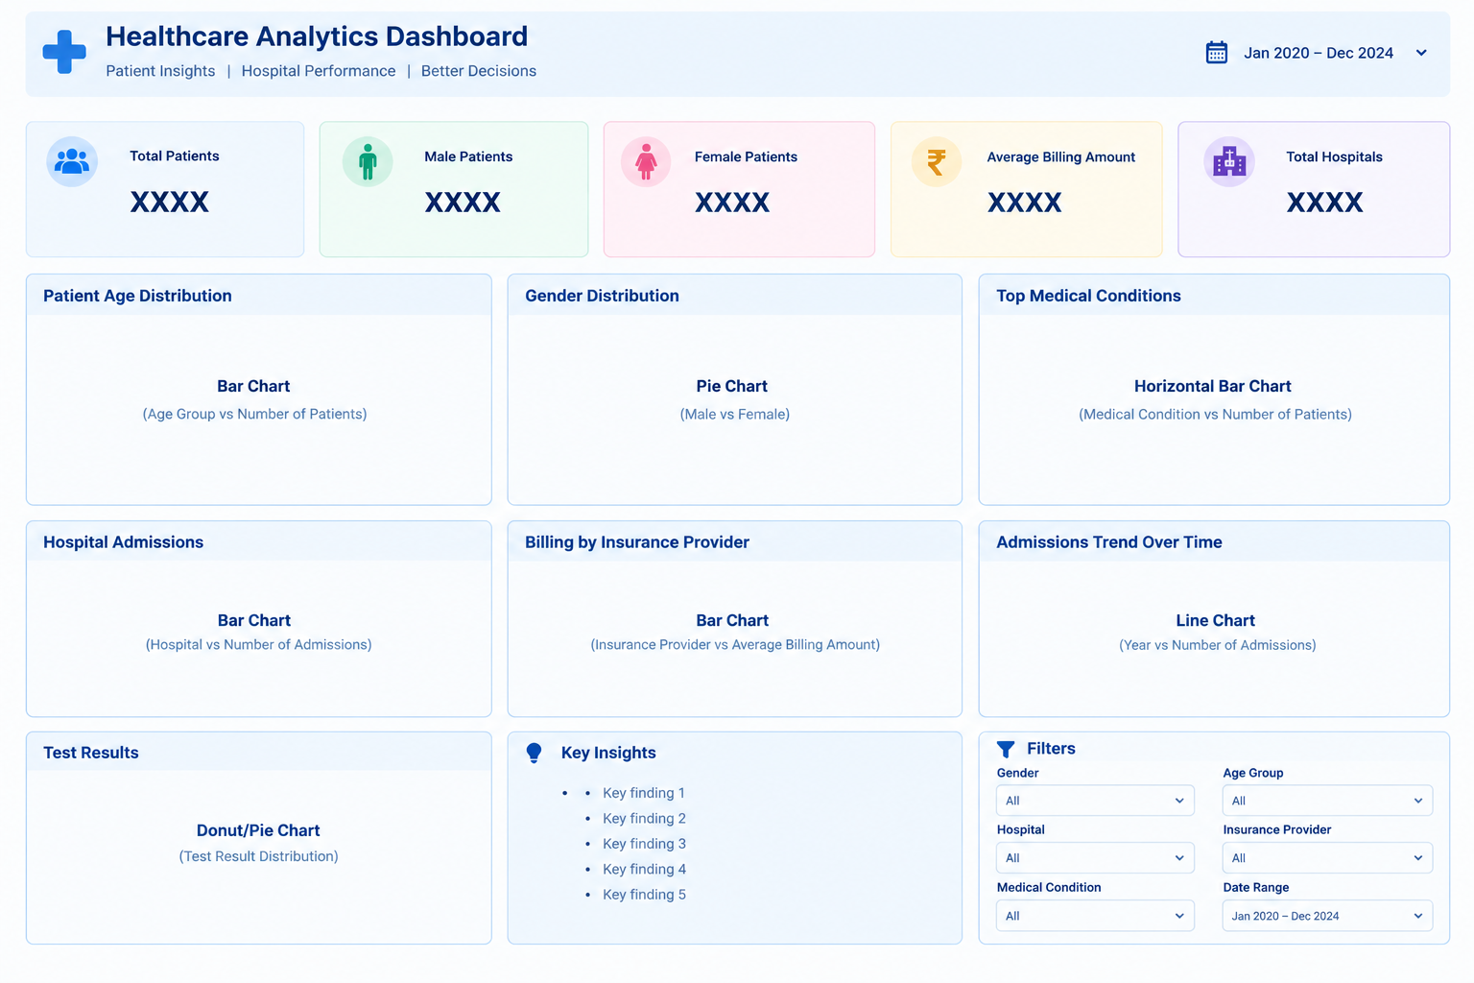

- Key Performance Indicators

The dashboard uses KPI cards to give stakeholders an immediate overview before they examine individual charts.

KPI | Displayed Value | Interpretation | Management Use
Total Patients | 54,966 | Overall patient volume represented in the dashboard | Capacity and workload planning
Male Patients | 27,496 | 50.02% of displayed patients | Demographic monitoring
Female Patients | 27,470 | 49.98% of displayed patients | Demographic monitoring
Average Billing | ₹25.55K | Average billing amount shown | Financial monitoring
Hospital Metric | 39,876 | Value displayed in the dashboard's Total Hospitals card | Requires definition/validation before being interpreted as unique hospitals

The male/female counts are almost evenly balanced: the displayed dashboard reports 27,496 male and 27,470 female patients. This corresponds to approximately 50.02% and 49.98%, respectively. The balance means that large gender-based differences should not be assumed without examining other dimensions such as condition, age, admission type, or billing.

- Dashboard

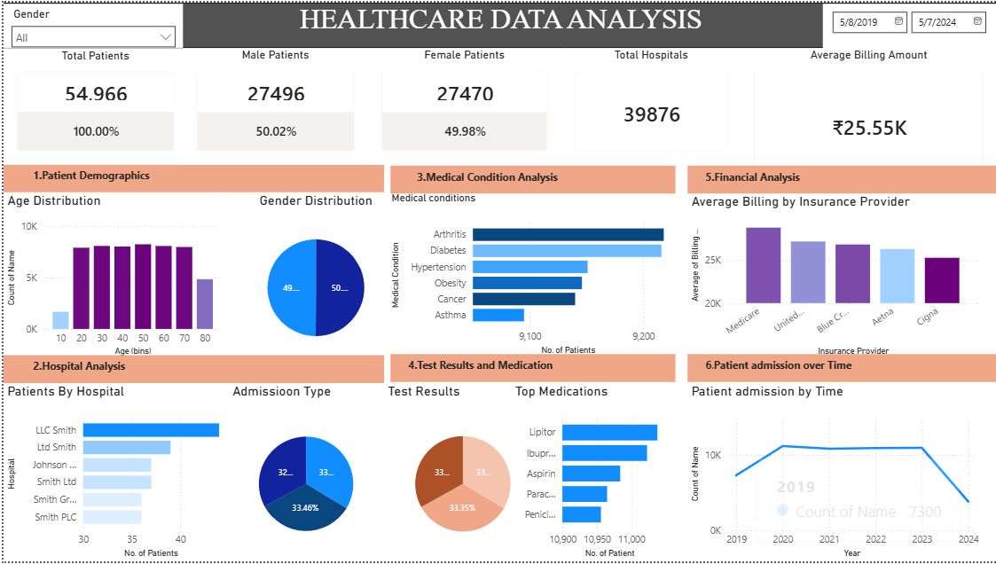

Detailed Exploratory Analysis and Insights

- Patient Demographics – Age Distribution
The age distribution is presented using a bar chart with age bins from approximately 10 through 80. The chart shows relatively similar volumes across several middle-age bins, with the 50–60 range appearing among the highest volume groups. The submitted analysis specifically identifies the 50–60 age group as the highest age group.
Decision support: Hospital administrators can use this distribution when reviewing outpatient capacity, department demand, staffing, and preventive-care programs. If the 50–60 group consistently represents a large share of patients, service planning can be aligned with the clinical needs of that population.

- Gender Distribution
The dashboard reports 27,496 male patients and 27,470 female patients. The corresponding shares are 50.02% and 49.98%. The difference is only 26 patients, indicating an almost perfectly balanced gender distribution in the displayed data.
Decision support: Because the overall population is balanced, administrators should avoid allocating resources solely on the basis of overall gender counts. Instead, gender can be used as a filter to compare condition rates, admission types, or billing patterns within each group.

- Medical Condition Analysis
The medical-condition bar chart compares Arthritis, Diabetes, Hypertension, Obesity, Cancer, and Asthma. The dashboard identifies Arthritis as the most common condition among the displayed conditions. The bars for Arthritis and Diabetes are visibly higher than the remaining conditions, while Asthma has the lowest displayed count among these six categories.
Decision support: Condition frequency can guide staffing, clinical resource planning, awareness programs, and inventory planning for commonly required treatments. The chart should be treated as a workload indicator rather than a measure of disease severity.

- Hospital Analysis
The hospital comparison ranks displayed hospitals by patient count. LLC Smith is the leading hospital in the dashboard comparison, followed by Ldt Smith and other hospitals shown in the chart.
Decision support: Hospitals with higher patient volumes may require closer monitoring of staffing, beds, diagnostic capacity, and appointment availability. A high patient count alone does not mean that a hospital is inefficient; it is a signal for further analysis using capacity, waiting time, outcomes, and length-of-stay data.

- Admission Type Analysis
The admission-type visualization is shown as a pie chart and divides patients into the admission categories available in the dataset. This helps administrators understand how patients enter the healthcare system.
Decision support: Admission mix can be compared with staffing and facility capacity. For example, a high share of emergency admissions may require different staffing and resource planning from a system dominated by scheduled admissions.

- Test Results and Medication
The dashboard presents test-result categories using a pie chart and medication frequency using a horizontal bar chart. The submitted analysis reports that 33.35% of patients have normal test results. The medication chart shows Lipitor, Ibuprofen, Aspirin, Paracetamol, and Penicillin among the leading displayed medications.
Decision support: The normal-result percentage can be used as a monitoring metric for diagnostic workload, but it should not be interpreted as a clinical quality score without additional context. Medication frequency can support inventory planning and identify commonly prescribed medicines, subject to clinical validation.

- Financial Analysis
The dashboard reports an average billing amount of ₹25.55K. The insurance-provider chart compares average billing across providers, with Medicare appearing highest among the displayed providers. Other displayed providers include United..., Blue C..., Aetna, and Cigna.
Decision support: Comparing average billing by insurance provider can help finance teams identify differences in billing patterns and prioritize further investigation into reimbursement, service mix, patient complexity, or coding practices. The chart should not be used alone to conclude that one insurer is more profitable.

- Patient Admissions Over Time
The line chart covers years from 2019 through 2024. The displayed trend rises from 2019 to 2020, remains relatively stable across 2021–2023, and then drops sharply in 2024. The dashboard therefore provides a useful starting point for identifying periods requiring investigation.
Decision support: A sudden decrease should trigger validation of data completeness and date coverage before operational conclusions are made. If confirmed as a real decline, management could investigate changes in patient demand, referral patterns, service availability, or reporting processes.

- Python Implementation

- Descriptive Statistics
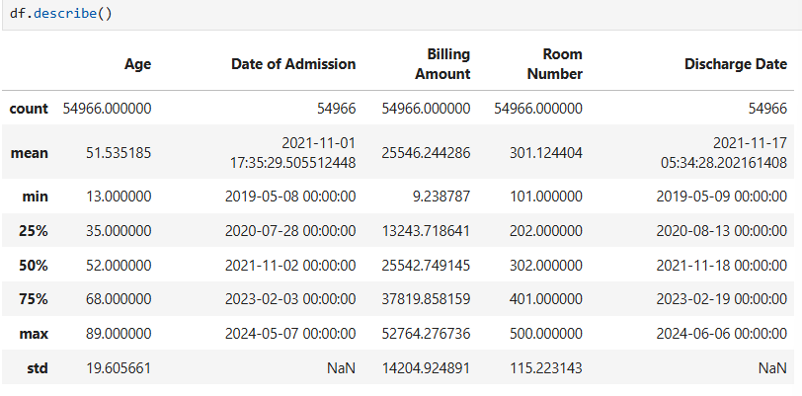

- KPI Calculations

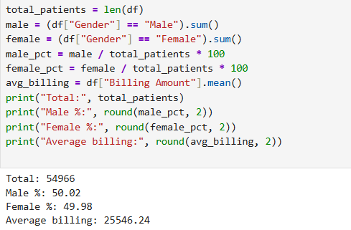

- Age Distribution
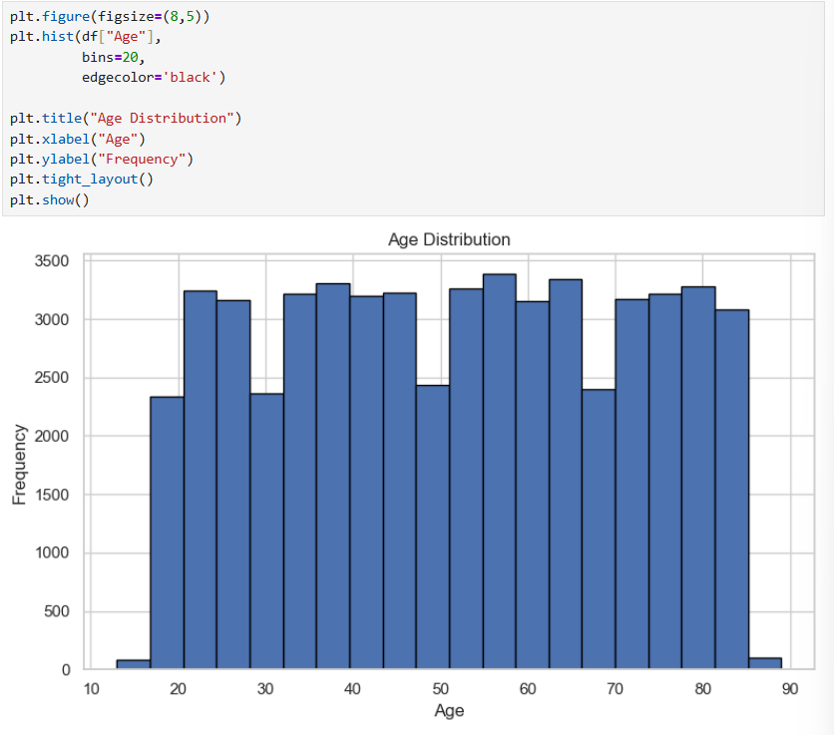
- Medical Conditions
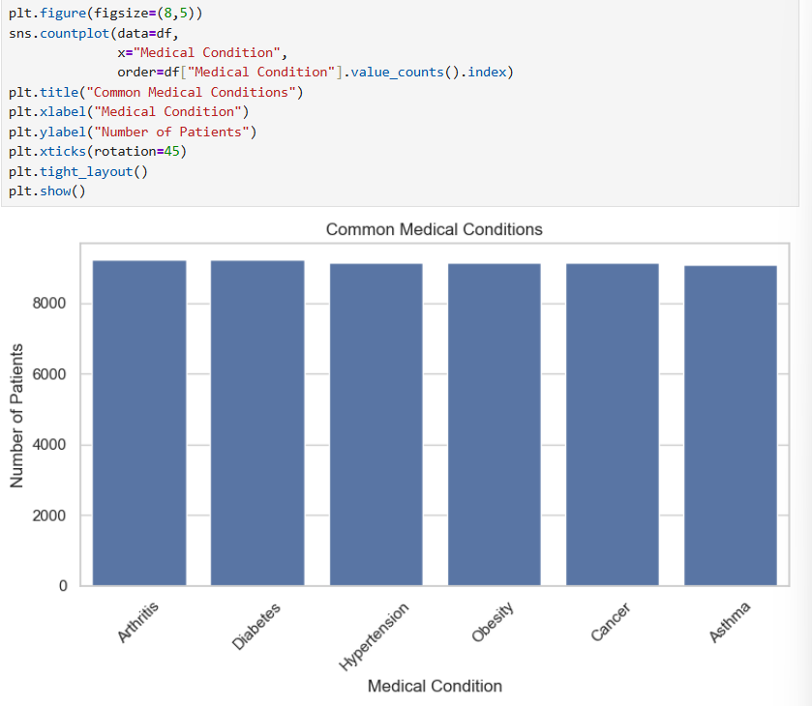
- Admission Type Comparison
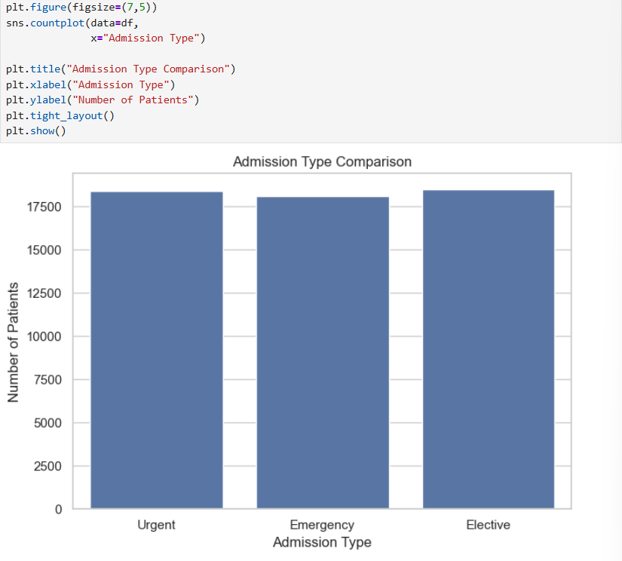
- 10.7 Billing by Insurance Provider
- 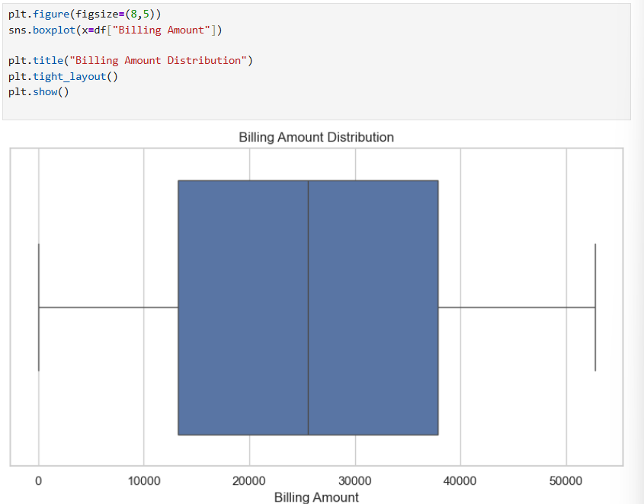
- 10.8 Admissions Over Time
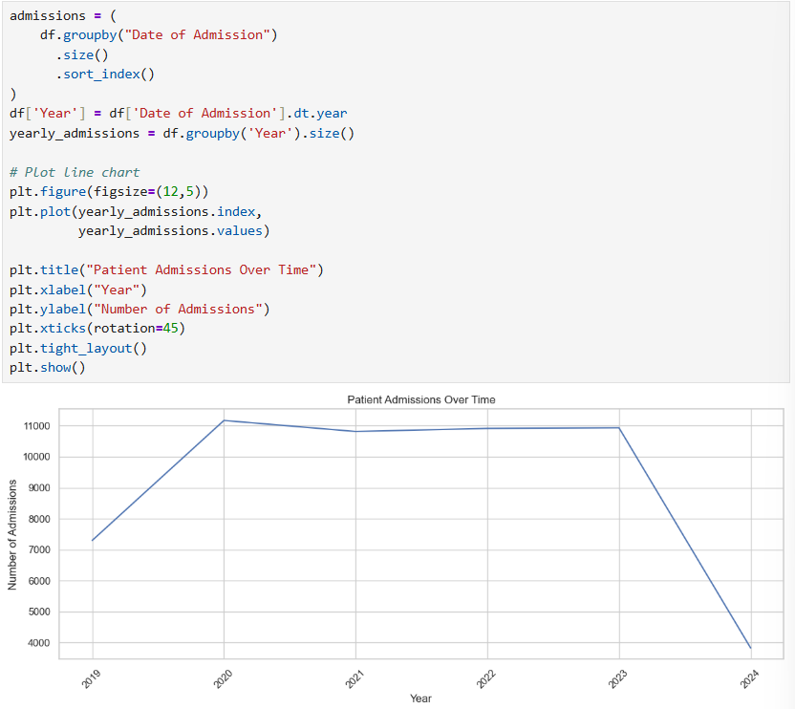

- Insight To Decision Framework

Observed Insight | What It May Indicate | Recommended Next Analysis | Potential Decision
50–60 is among the highest-volume age groups | High workload from middle-aged patients | Cross-tab age with condition and admission type | Adjust service capacity if pattern persists
Gender split is 50.02% / 49.98% | Balanced overall population | Compare gender by condition and billing | Avoid broad gender-based resource assumptions
Arthritis is the leading displayed condition | Higher relative workload for this condition | Analyze condition by age, gender, and hospital | Plan relevant clinical resources
LLC Smith leads displayed hospitals | Higher patient volume | Compare volume with capacity and waiting time | Review staffing/capacity
Medicare has highest displayed average billing | Different billing pattern | Check service mix and reimbursement details | Finance team investigation
33.35% normal test results | One-third of displayed test-result category | Cross-check by condition and hospital | Monitor diagnostic workload
2024 shows a sharp decline | Possible demand or data-coverage change | Validate records and date completeness | Investigate before operational action

- Insight Communication

The visualizations will help answer questions such as:
- Which age group has the highest number of patients?
50-60 Age group has the highest number of patients.
- Which medical conditions are most common?
Arthritis is the most common medical condition.
- Which hospitals admit the most patients?
LLC Smith hospital admits the most person.
- Which Insurance provider provides the most billing amount?
Medicare Provide the most billing amount
- What percentage of patients have normal test results?
33.3% patients have normal test results.
- Conclusion

Data visualization transforms healthcare data into meaningful graphical insights that are easier to understand than raw tables. The proposed dashboard and visualizations will help identify trends, monitor hospital performance, and support better healthcare decisions. This phase prepares the project for statistical analysis and predictive modeling in the next stage.

